

PROJECT REPORT

Prepared by:
Aruana Sadubayeva,Kenessary Garifulla,Arlan Toktarkhan
Information systems in business
Submitted to:
Alisher Aldashev

Almaty, 2024-2025

EXECUTIVE SUMMARY
The report provides a detailed analysis of sales, profitability and logistics performance in global markets for diverse product categories over the four years from 2020 to 2023.
The Market Analysis Dashboard obtains the general statistics of sales, quantity sold, and profitability across international markets. APAC is defined as the major consumer in terms of sales. The Canada individually cumulates the minor contribution; however, this market has the highest recoupment per dollar. Some regions showed a magnificent annual sale increase, while others could not catch up with the volume.
Regarding the Logistic Performance Dashboard, it indicates that standard shipping is the most frequent, where the opportunity cost of price is the long delivery time. Under the categories of Office Supplies, Binders take the lead in orders; however, sub-categories under Furniture, such as Tables, are poorly demanded. Regional disparities in shipping and orders highlight areas for logistical improvements.
The General Overview Dashboard collects the insights of cumulative profit by each month, likewise, its distribution between all countries. States with access to the Pacific Ocean tend to have substantial profits. In addition, there was given an analysis of sub-categories within sales, number of orders and the interactions of profit and discount amount. Office supplies, like ‘Binders’, ‘Storage’, ‘Art’ and ‘Paper’ aggregate the greatest number of orders, followed with ‘Chairs’ and ‘Phones’.
The Geographic Analysis Dashboard identifies the top profit contributors to be the United States and China, while Africa and South America show lags in sales and profits, thus opportunities for growth. As for Eurasian countries, developing countries generate low sales volume, besides the highly populous countries.
Finally, a separate review of product categories is given by the Category Profit Analysis Dashboard. Most of the product number is occupied by office supplies – approximately two thirds of total quantity. In spite of the large profit volume of technological devices, they are exposed to be medium in profit margins. Furniture has a poor profit outcome, due to few units sold.

TABLE OF CONTENTS
1.INTRODUCTION 4
2.KEY INSIGHTS FROM THE DASHBOARDS 5
2.1 MARKET ANALYSIS DASHBOARD 5
2.2 LOGISTICS PERFORMANCE ANALYSIS 7
2.3 GENERAL OVERVIEW DASHBOARD 9
2.4 GEOGRAPHIC ANALYSIS DASHBOARD 11
3.RECOMMENDATIONS FOR SENIOR MANAGEMENT 15
4.CONCLUSION 16

1.INTRODUCTION
The purpose of this report is to expose commercial insights through the analyses of specific branches in the worldwide market. There are several dashboards, consisting of various charts that shape an overview of market performance.
In an increasingly competitive business environment, this business analysis provides the basis for empirical recommendations, that is the intention of offering tools to solve problems and exploit opportunities. Throughout the period from 2020 to 2023, it was determined that some parts of the world had own potential aspects, however the other regions showed different outcomes.
The interrelationships of key operational factors were derived, and conclusion was provided in order to assist in making decisions about future growth, cost reduction and competitive positioning in the market.

2.KEY INSIGHTS FROM THE DASHBOARDS

2.1 MARKET ANALYSIS DASHBOARD
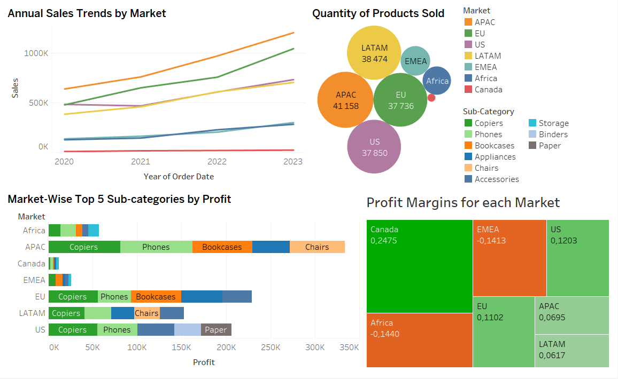
The dashboard shows the global contribution to sales in individual markets and the volume of profits in these markets for the period from 2020 to 2023.
Annual sales trends by market
The line graph illustrates the results of sales for each multinational market. There can be seen an identical trend, which is upward, with different growth rates in sales. The leading position was held by APAC each year, reaching the highest value of $1,207,384. LATAM had a steady growth, while the US market declined by approximately $15,000 from 2020 to 2021. In contrast, the other markets demonstrated slower growth in sales, where the Africa and EMEA markets accounted for only a quarter of APAC’s sales each, annually.
Quantity of products sold (in each market)
The total quantity of products sold by each market almost coincides with the sales contributions with the same leaders as the sales chart. There is a fact that the quantity of products sold in the market of EU is smaller than those in the US and LATAM, which indicates that in the Europe there were a higher valued sales per order.

Market-wise top 5 sun-categories by profit
In general, we can underline ‘Copiers’ and ‘Phones’ from technological products as two of the most profitable sub-categories for each market. As for office supplies, ‘Appliances’ has the greatest profit and it appears among top 5 profit leaders in all markets, except for APAC. Regarding the furniture category, bookcases and chairs are common products and the largest amount of profit earned is in APAC ($67,456 and $62,134, respectively).
Profit margins for each market
The markets that have lower growth rate (EMEA and Africa) in sales appear to have negative profit margins, except for Canada. The market of Canada has a minor share in sales; however its profitability is 24.75%, on average, which is more than two times greater than in the US or the EU.

2.2 LOGISTICS PERFORMANCE ANALYSIS
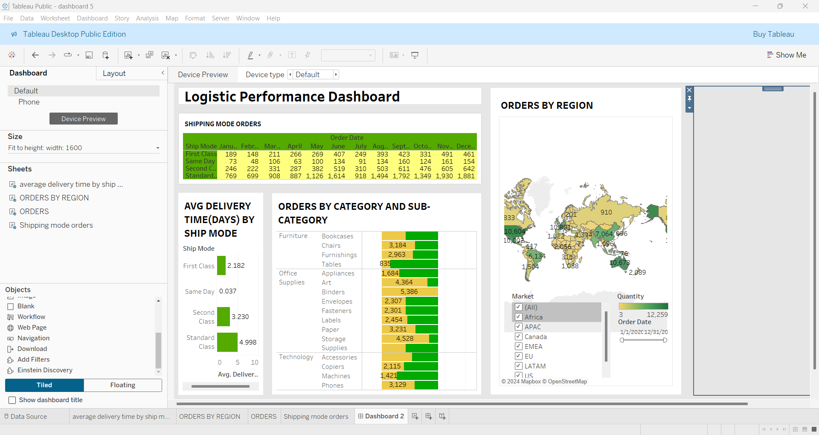
The given Logistic Performance Dashboard presents an overview of important information on transportation methods, product expectations and regional indicators that helps to identify some sectors for improvement.
Shipping mode orders and average delivery time by ship mode:
If we analyse the table, it can be seen that the standard shipping mode orders is the most popular among all ship mode reaching 1930 orders per November. Meanwhile, the highest orders for first class and same day are 491 and 161 respectively. However, the average delivery time for standard class is the slowest (4.998 days) compared to the first class (2.182 days) and same day(0.037 days).The same day shipping mode order is rarely used by clients despite the fact there is the fastest average delivery time.
The “orders by region” map illustrates that the leaders in purchases are USA (10 604 orders) and Australia (10673 orders), while Namibia and Mongolia provide us with low number of orders, only 30 and 71 respectively. The APAC region demonstrates some variability in purchases. For example, China accounts for 7064 orders, while Slovakia has only 18 orders.
According to orders by category and sub-category, binders are considered the most popular items in office suppliers having 3,129 orders, whereas tables in the furniture lag behind with just 835 orders. Furthermore, it is visible that phones are most popular for orders in the category technology which accounts for 3,129 orders. If the businesses pay more attention to high-demand products, such as binders and phones, they can reach better outcomes.
Overall, it is preferable to address the issues of shorter delivery times and performance differences between regions. Moreover, it is obtained that logistic preferences can be improved by focusing on high-demand product categories such as office suppliers, optimizing standard class deliveries and integrated services.

2.3 GENERAL OVERVIEW DASHBOARD
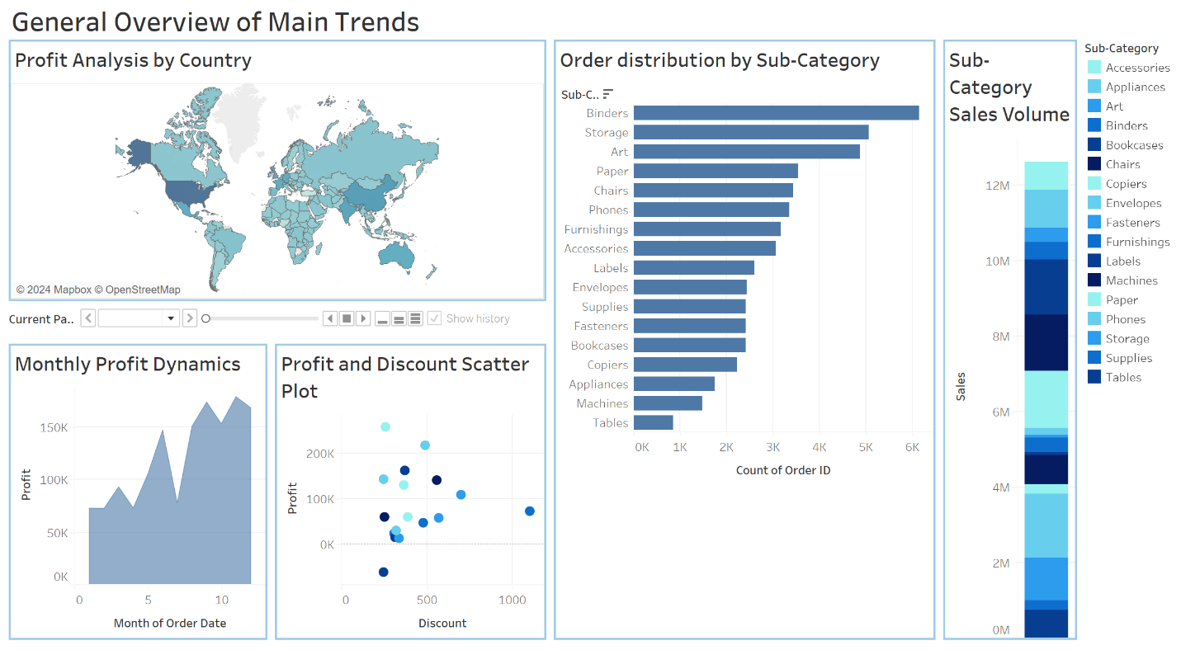
The dashboard provided above represents the general analysis of profit dynamics by country and month, profit and discount relationship, order and sale distribution by sub-category.
“Profit Analysis by Country” demonstrates the profit volume of each country by year (2020-2023). Countries like the USA ($286,295), China ($150,535), India ($128,699), Mexico ($102,804), Australia ($103,907), UK ($111,483), France ($108,812), Germany ($107,302) tend to show the highest cumulative profits. According to the chart, the profit percentage increase was evaluated, with the best-performing countries such as India - 144,6%, France – 92%, USA – 89% and UK – 82%.
“Monthly Profit Dynamics” represents the profit trends by month. There can be seen a gradual tendency for profit to increase throughout the year, with the highest profits in November and December with $1,568,644 and $1,561,293 respectively. The lowest profits are observed at the beginning of the year, especially in February ($558,888) that is approximately half of the peak.
“Profit and Discount Scatter Plot” shows some relationship between profit and discount across the sub-categories. There is a weak positive correlation between the variables, with the only “Tables” sub-category showing negative profit. Whereas the “Binder” product with greatest discounts demonstrates moderate profit.

“Order distribution by sub-category” and “Sub-category Sales Volume” charts highlight both demand and resulted sales of each sub-category. According to the first graph, Binders (6,145 ids), Storage (5,053 ids) and Art (4,881 ids) are the most-ordered products, whereas they result in moderate sales with $461,706, $1,126,094 and $372,022 respectively. Meanwhile, moderate-ordered products like Phones (3,353 ids), Copiers (2,218 ids) and Chairs (3,431 ids) produce the highest sales with $1,705,436, $1,505,713 and $1,500,977 respectively.

2.4 GEOGRAPHIC ANALYSIS DASHBOARD
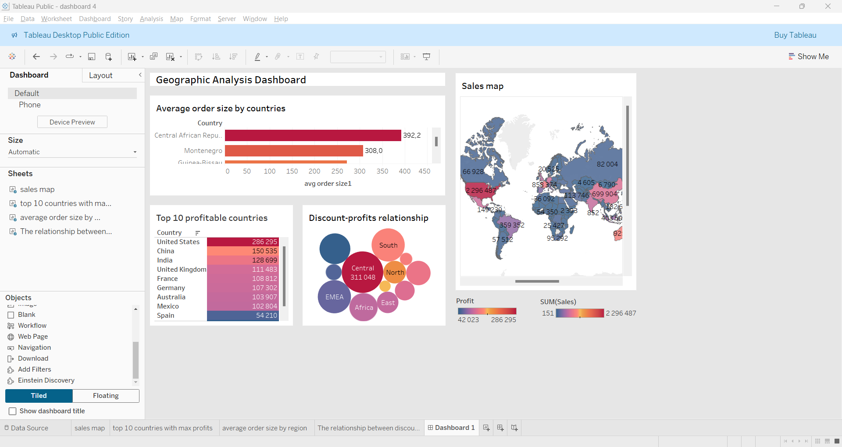

The given Geographic Analysis Dashboard provides key information regarding sales by regions, profitability of the countries and the relationship between discounts and profits.
Top 10 profitable countries
From the table, it can be seen that the US experience the highest profits ($286,295), China is in second place with profit ($150,535) and India accounts for ($128,699) that closes out the top three. Of the top 10 countries, El Salvador have the lowest profit ($42,023) representing significant growth potential in this state.
Discount-profits relationship
As can be seen from the bubble chart, Central Asia region has the highest profit ($311 048) and the high discount rate. On the other hand, North Asia has a profit of $165 431 and the low discount rate among all regions. The lowest profit is accounted for in Southeast Asia ($18,959) despite the relatively high discount rate. There is an important insight indicating that high discounts do not necessarily lead to high profits.
Average order size by countries
The chart given demonstrates significant variability in the average order size across regions. The highest average order size was identified in Central African Republic ($392,2), Montenegro ($308.0) and Guinea-Bissau ($271.2). Countries with the lowest average order size are Sri Lanka ($6.6), Papua New Guinea ($8.9) and the United Arab Emirates ($16.1). The moderate averages are accounted for states such as Lebanon ($103.5), Finland ($103.2) and Senegal ($102.7), highlighting the stability of consumer behavior.
The given “sales map” illustrates that the biggest volume of sales is in America ($2 296 487), followed by China ($699 904) and Germany ($628 547). In contrast, Japan and Russia experience lower sales, ($100 788) and ($82 004) respectively. India with the volume of sales ($588 639) is considered as stable, while Brazil ($359 352) is a distant second in South America.

2.5 CATEGORY PROFIT ANALYSIS DASHBOARD
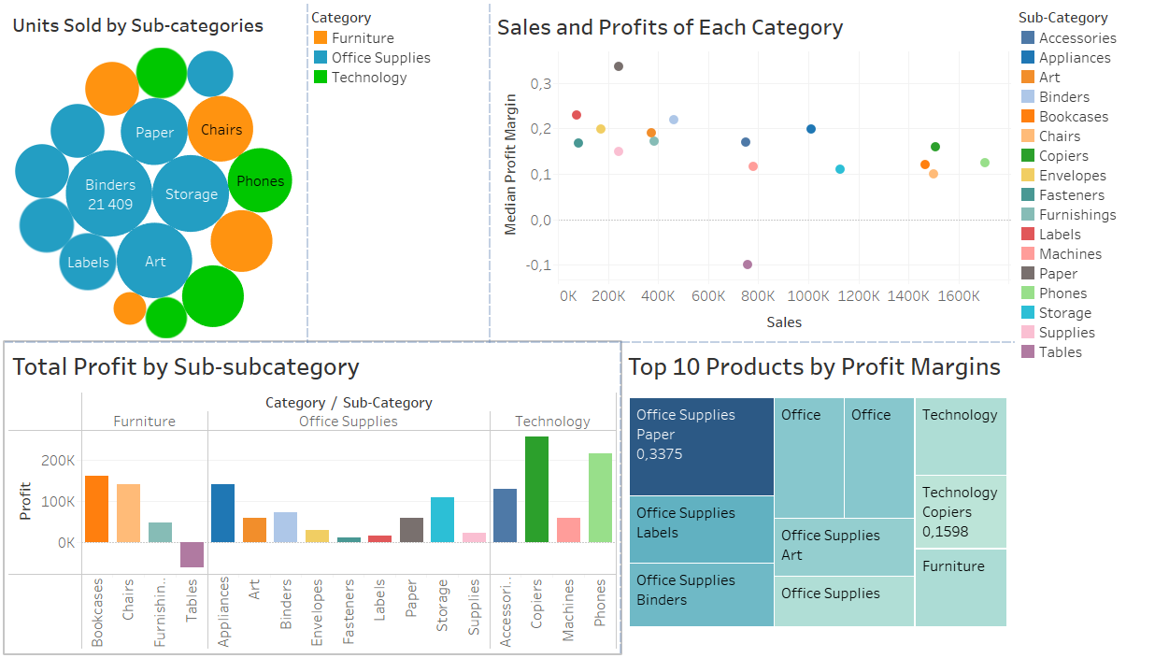
The dashboard provides a detailed view of sales and profitability across categories and sub-categories, where the interconnections between sales volume, profit generation, and margin efficiency are key metrics.
Units sold by sub-categories
It can be seen that ‘Office Supplies’ occupies the major share of sales in terms of quantity. ‘Binders’, ‘Storage’ and ‘Art’ sub-categories sum up to 21409, 16901 and 16296 units, accordingly. For ‘Technology’, ‘Phones’ and Accessories’ amount to over 10 thousand units each (11851 and 10926 units), whereas those are ‘Chairs and ‘Furnishings’ in the furniture market (12328 and 11220 units).
Sales and profits of each category
The scatterplot identifies that ‘Phones’, ‘Copiers’, ‘Chairs’, and ‘Bookcases’ are primary sales contributors with the values of over 1.5 million dollars each. Nevertheless, these categories, as it turned out, are not the most cost-effective. Besides relatively low total sales, ‘Papers’, ‘Labels’ and ‘Binder’ have significantly higher margin efficiency, where paper products bring a median of 33.75%. There is only one sub-category with a negative margin which creates a loss in sales – ‘Tables’.

Total profit by sub-category
While the profit margins for the above four sub-categories do not generally excel between categories, they appear to generate enormous profit volume. There are ‘Bookcases’ and ‘Chairs’, that have made over 100 thousand dollars in furniture category. Turning to office supplies, that can be claimed only for ‘Appliances’ and ‘Storage’ ($142,606 and $108,151, respectively).
Top 10 products by profit margins
Similarly like in the bubble chart, the tree map emphasizes the dominance of Office Supplies as the most efficient category. Products like Paper and Labels achieve the highest profit margins (0.3375 and 0.2292, respectively), despite moderate profits and sales. The transportation costs per unit tend to be distributed as the results of large quantity demanded. The last of 10 most profitable sub-categories are ‘Accessories’ and ‘Copiers’ with 16.99% and 15.98% respectively. This means the sales of technological products are critical reason why they create substantial profit.

3.RECOMMENDATIONS FOR SENIOR MANAGEMENT
Generally, it is recommended to invest in the US (0,1203) and EU (0,1102) regions due to high profit margins. Even though APAC region leads in sales with 1.2 million dollars in 2023, it lacks profit margins (0,0695), it needs managerial consideration. Regions like EMEA and Africa are expected to be strategically renovated due to negative average profit margins and slow growth rates. Some standard delivery time enhancements suggested, as they can improve customer loyalty among competitors. Basically, the USA (10,604 ids), Australia (10,673 ids), Germany (7,734 ids), China (7,064 ids) are leading in orders volume, highlighting they attractiveness for market expansion. Meanwhile, Africa and Latin America produce the lowest demand and need some renovation approaches.
Overall, the agents should mainly rely on developing and sustainable markets in the USA, China, India, Mexico, Australia, UK, France, Germany. Especially, countries like India, France, USA and UK, resulted in the greatest profit increase starting from 2020, indicating their market growth. However, underperforming markets in Japan, Russia highlight potential for growth. Managers should focus on Technology and Furniture products like Phone, Copiers, Chairs, Bookcases, which are the most-sold ones, with increasing profit trends. However, Tables resulted in negative profit of $29,351 in 2023, managers need to address the problem. It is also recommended to prepare for increased demand in June, September, November, and December with targeted promotions and efficient logistics. Managers are expected to consider the relationship between profit and discount across sub-categories and regions, with the remark that correlation does not always imply causation.

4.CONCLUSION
To sum up, the given report presents key insights on global sales, profitability, logistic performance and suggests actionable recommendations for senior management. The key information includes the US dominance in profitability due to its focus on high-margin products and Asian-pacific leadership position in the volume of sales. It is obtained that there are some operational challenges in regions such as Africa, the Middle East and North Africa and these states must do more to ensure growth and profitability. Customer satisfaction and efficiency can be improved by optimizing logistics through focusing on delivery quality. Moreover, product strategy needs to balance clarity and profitability by focusing on high-demand products such as mobile phones and binders while preserving underperforming product categories such as furniture. The provided recommendations are aimed at leveraging the strengths of each region, improving pricing and discounting methods, and enhance logistics capabilities. Achieving operational excellence, increased competitiveness and sustainable growth can be done by focusing on these key regions. The recommended strategies represented in this paper provide with key information for operating effectively and seizing new opportunities in a challenging market environment.

